W B. School of Engineering Practice & Technology - McMaster University

Senior Engineer Project - SFWRTECH 4FD3



|  |  |
| --- | --- |
| **Date**  **Type**  **Proposed Project title**  **Short Description** | Jan 16, 2022  Course Project  Flashminder  An Assistive Learning tool for building memory |
|  |  |
| **Supervised by**  **Team Members** | Dr. Seshasai Srinivasan  Chandra Rai  Student No. 400351588  raic1@mcmaster.ca  Emily Goodwin  Student No. 400352097  goodwe2@mcmaster.ca  Stefan Slehta  Student No. 400291135  slehtas@mcmaster.ca  Violet Huang  Student No. 400348357  huanx34@mcmaster.ca |

**Problem Description**

We learn things everyday. There are things that we need to remember for our survival. However, forgetting can be infuriating when students try to learn skills especially in school, colleges, and universities. A research has indicated that learned information fades over time.

Forgetting curve

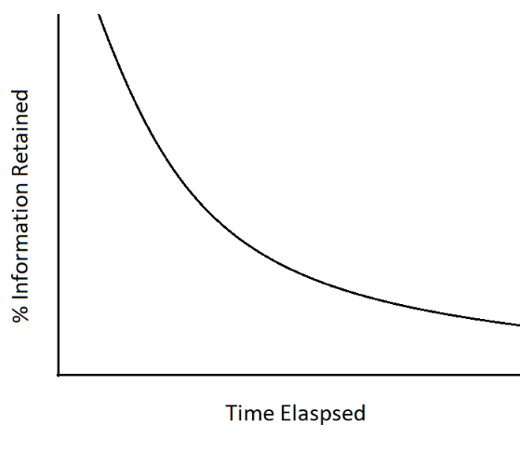

*(Diagram – 1)*

How can we boost memory? There are few strategies to prevent forgetting such as recall memory in timed intervals, make information meaningful, keep challenging memory etc. This is where Flashminder comes in.

**Solution**

Initially, it is anticipated that the completion of this project will provide the following solution to the problem:

* Quiz user at timed intervals using spaced repetition using the SM-2 Algorithm thereby helping improve memory
* Prompt user via notifications instead of waiting for the user to action on their own thereby allowing to set learning goals and expediating those goals
* Maintain correct status of user learning experience such as study area of interests, level of difficulty, priority etc. thereby improving learning pace and making quality experience.